**Leland Randles DATA606**

Homework, Chapter 7

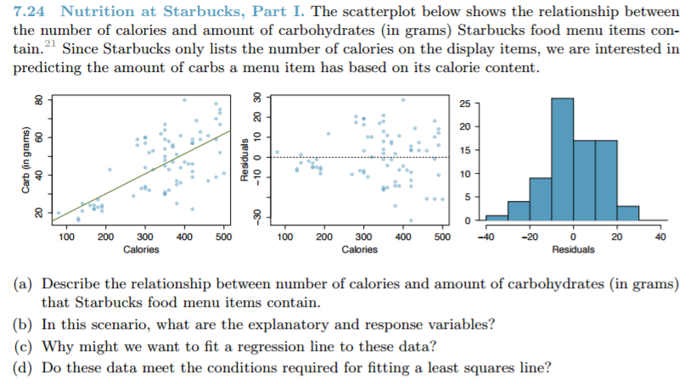

1. Fairly linear. More variability on the right of the plot than the left. Not many outliers.
2. Calories is the explanatory variable and carbohydrates is the response variable.
3. To predict the amount of carbohydrates in a menu item based on the calories (since only calories are listed by Starbucks).
4. The linearity condition, the residuals are nearly normal, there is nearly constant variability, and the observations appear to be independent. So, yes.

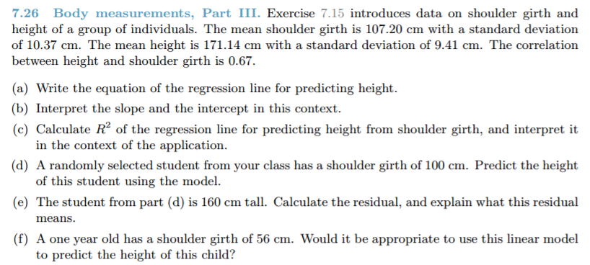

1. You can estimate the slope of the least squares line by taking the standard deviation of shoulder girth divided by the standard deviation of the height and multiplying it by the correlation: (10.37 / 9.41) * 0.67 = 0.738

Then the point estimates can be used to build the equation:

y – 171.14 = 0.738 * (x – 107.2)

y = 0.738x + 92.0264

1. The y-intercept suggests that someone who is 92.0264 centimeters tall would have a shoulder girth of 0, and that each additional centimeter of shoulder girth would add 0.738 centimeters of height.
2. R2 = 0.672 = 0.4489. This means 44.89% of the variability in height can be explained by shoulder girth.
3. Height = (0.738 * 100) + 92.0264 = 165.8264 centimeters
4. The residual is 160 – 165.8264, or -5.8264 centimeters. The residual helps determine how well the linear model fits the data set.
5. No, one should not extrapolate outside the model.

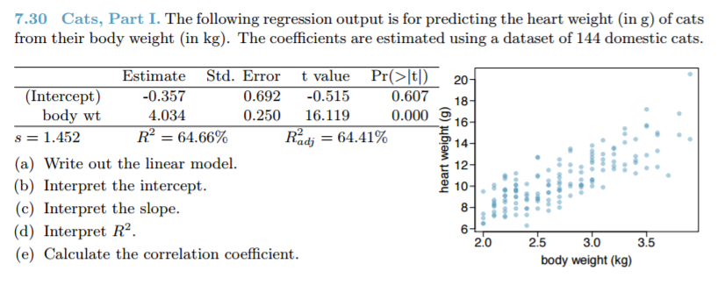

1. Heart weight = -0.357 + 4.034 * body weight
2. It says that if someone had a body weight of zero kilograms, their heart weight would be -0.357 grams (of course neither is possible).
3. The slope is telling us that for every one-kilogram increment up or down in body weight, the heart weight increases (or decreases) by 4.034.
4. The R squared of 64.66% tells us that 64.66% of the variability in heart weight can be explained by body weight.
5. The correlation coefficient is the sqaure root of R2, which is 0.804.

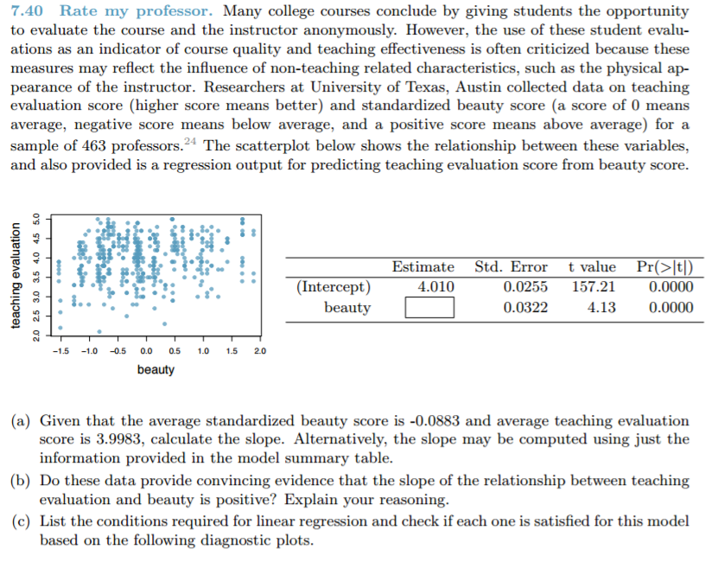

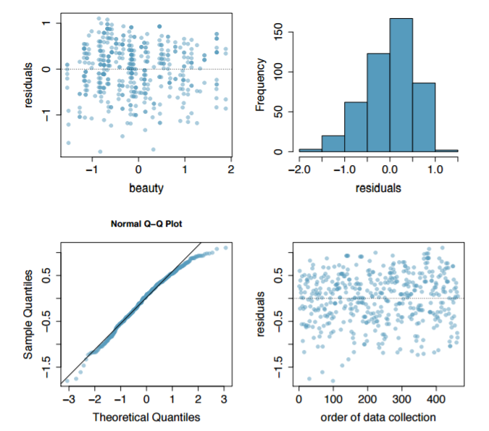

1. y – (- 0.0883) = ((0.0322 / 0.0255) * *R*) * (x – 3.9983). We don’t have the correlation *R*, so not sure how to compute.
2. The p-values are very low, which suggests beauty DOES have a strong relationship to teacher ratings.
3. Conditions:
   1. Linearity – Q-Q plot suggests linearity
   2. Nearly normal residuals – some left skew, but pretty close
   3. Constant variability – Looks pretty good on the residual plot
   4. Independent observations – there is no reason to believe the observations were not independent